MAHARAJA AGRASEN INSTITUTE OF MANAGEMENT STUDIES

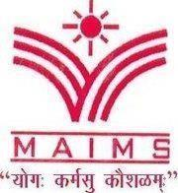
(A unit of Maharaja Agrasen Technical Education Society) Affiliated to GGSIP University; Recognized u/s 2(f) of UGC
NAAC Accredited with Grade “A++”
Recognized by Bar Council of India; ISO 9001: 2015 Certified Institution Maharaja Agrasen Chowk, Sector 22, Rohini, Delhi - 110086, INDIA Tel. Office: 8448186947, 8448186950 - www.maims.ac.in

DEPARTMENT OF COMMERCE
Email: hodcommerce@maims.ac.in Prof. (Dr.) Manju Gupta
Ph:9811871455 Head, Department of Commerce Tuesday, 10th March, 2026

Session on AI Is a Tool, Not a Threat: How Students Can Use AI to Get Ahead?
Academic Year: 2025-26

Name of Event: Session on AI Is a Tool, Not a Threat: How Students Can Use AI to Get Ahead?

Organised by: Department of Commerce, MAIMS
Date of the Event: 10th March 2026
Time of the Event: 12:00 PM – 1:00 PM
Location: Seminar Room, 9th Block

Number of Participants: 77

About the Session
The Department of Commerce, Maharaja Agrasen Institute of Management Studies (MAIMS), organised a session on AI Is a Tool, Not a Threat: How Students Can Use AI to Get Ahead?, with the objective of enhancing students’ understanding of Artificial Intelligence and its use. The session commenced with the formal felicitation of the resource persons. The Head of the Department of Commerce, Prof. (Dr.) Manju Gupta warmly welcomed the distinguished speakers and felicitated them with mementos and saplings as a token of appreciation.
The session was conducted by Ms Tamanna Madan, Senior Product Manager at S&P Global. She enlightened the students about the Leveraging Knowledge Platforms for AI-Powered Financial Insights. She also explained how Deeper integration with S&P data helps solve complex use cases. Through practical examples, she guided students on how to wisely and responsibly use artificial intelligence.
She also explained the need and importance of data with following example
If you were investing your own money, would you rely on data or intuition?
Finance decisions rely on data
  - Company financials
  - Market prices
  - Economic indicators
  - News & global events
- Without data, investors would basically be guessing.
- Analyzing information and turning it into decisions.
- Better data → Better financial decisions
The session was highly interactive, with students actively participating and raising queries related to AI and its use in investments, risk assessment, and financial planning. The session concluded with a vote of thanks, expressing gratitude to the resource persons for sharing her expertise and guiding students.
Glimpses of the Session
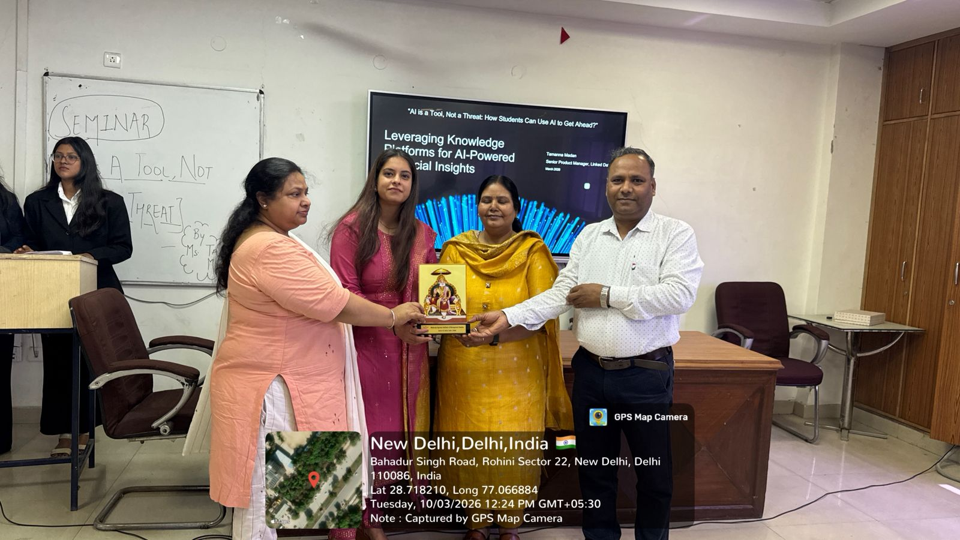
Felicitation of Resource Persons by HOD and convener, Department of Commerce
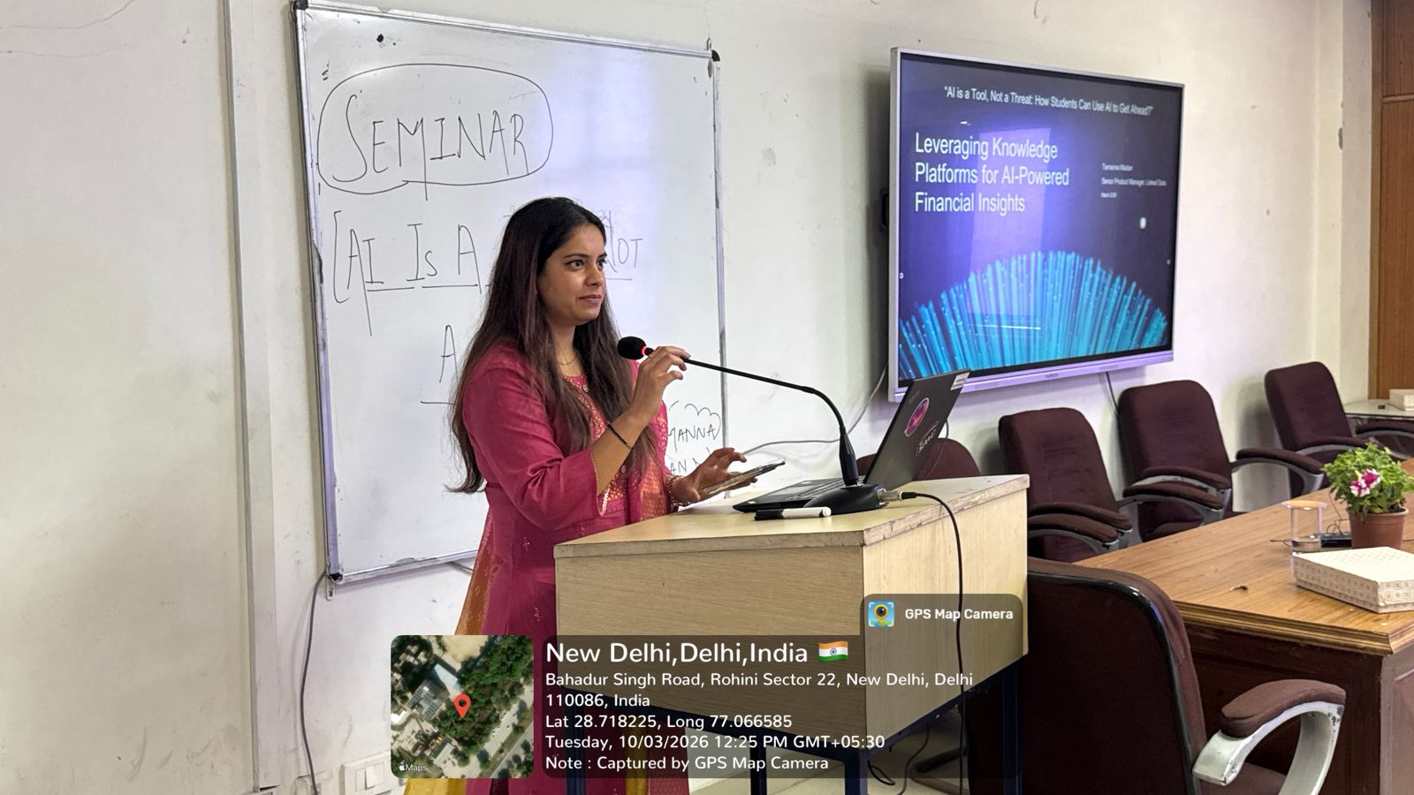
Ms. Tamanna Madam addressing the students
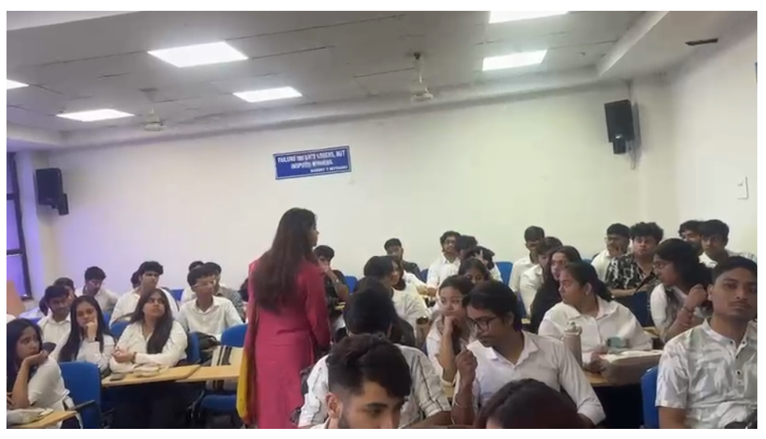

Interactive Q&A Session with Participants

Convener
Dr. Anil Kumar Goyal
Associate Professor, Department of Commerce
Contact: +91 8800605830

